
Machine Learning
Project – Election Data


Priyanka Pravinkumar Sukre
April’20 Batch.
Contents
1.1 Read the dataset. Describe the data briefly. Interpret the inferences for each. Initial steps like head() .info(), Data Types, etc . Null value check, Summary stats, Skewness must be discussed. 3
1.2 Perform Univariate and Bivariate Analysis. Do exploratory data analysis. Check for Outliers. (7 Marks) 5
1.3 Encode the data (having string values) for Modelling. Is Scaling necessary here or not? Data Split: Split the data into train and test (70:30). 12
1.4 Apply Logistic Regression and LDA (linear discriminant analysis). 13
1.5 Apply KNN Model and Naïve Bayes Model. Interpret the results 19
1.6 Model Tuning, Bagging (Random Forest should be applied for Bagging), and Boosting. 23
1.7 Performance Metrics: Check the performance of Predictions on Train and Test sets using Accuracy, Confusion Matrix, Plot ROC curve and get ROC_AUC score for each model. Final Model: Compare the models and write inference which model is best/optimized. 32
1.8 Based on these predictions, what are the insights? 33

List of Tables:

S No | Table
1 | Table 1.1 | Sample Dataset
2 | Table 1.2 | Null Values
3 | Table 1.3 | Data Types
4 | Table 1.4 | Statistical Summary of Dataset
5 | Table 1.5 | Skewness
6 | Table 1.6 | Categorical Variable Analysis
7 | Table 1.7 | Encoded Dataset
8 | Table 1.8 | Classification report on Train and Test Data for LR
9 | Table 1.9 | Classification report on Train and Test Data for LR Grid Search
10 | Table 1.10 | Classification report on Train and Test Data for LDA
11 | Table 1.11 | Classification report on Train and Test Data for Naïve Bayes
12 | Table 1.12 | Classification report on Train and Test Data for KNN
13 | Table 1.13 | Classification report on Train and Test Data for RF
14 | Table 1.14 | Classification report on Train and Test Data for Bagging
15 | Table 1.15 | Classification report on Train and Test Data for AdaBoosting
16 | Table 1.16 | Classification report on Train and Test Data for Gradient Boosting
17 | Table 1.17 | Inferences on AdaBoosing and Gradient Boosting
18 | Table 1.18 | Classification report on Train and Test Data for NB – SMOTE
19 | Table 1.19 | Classification report on Train and Test Data for KNN- SMOTE
20 | Table 1.20 | Inferences on NB-SMOTE and KNN-SMOTE
21 | Table 1.21 | Model Comparison table

List of Figures:

S No | Figures | Description
1 | Fig 1.1 | Distribution and Box Plots on Continuous Variables
2 | Fig 1.2 | Bi Variate Analysis on Age
3 | Fig 1.3 | Correlation Matrix
4 | Fig 1.4 | Sample Pair plot
5 | Fig 1.5 | ROC Curve on Training and Test data for Linear Regression
6 | Fig 1.6 | ROC Curve on Training and Test data for LR-Grid Search
7 | Fig 1.7 | ROC Curve on Training and Test data for LDA
8 | Fig 1.8 | ROC Curve on Training and Test data for Naïve Bayes
9 | Fig 1.9 | ROC Curve on Training and Test data for KNN
10 | Fig 1.10 | ROC Curve on Training and Test data for Bagging
11 | Fig 1.11 | ROC Curve on Training and Test data for AdaBoosting
12 | Fig 1.12 | ROC Curve on Training and Test data for Gradient Boosting
13 | Fig 1.13 | ROC Curve on Training and Test data for NB- SMOTE
14 | Fig 1.13 | ROC Curve on Training and Test data for KNN-SMOTE

Election Data:

Problem 1:
You are hired by one of the leading news channels CNBE who wants to analyze recent elections. This survey was conducted on 1525 voters with 9 variables. You have to build a model, to predict which party a voter will vote for on the basis of the given information, to create an exit poll that will help in predicting overall win and seats covered by a particular party.

1.1 Read the dataset. Describe the data briefly. Interpret the inferences for each. Initial steps like head() .info(), Data Types, etc . Null value check, Summary stats, Skewness must be discussed.

To start with the analysis let us start understanding the data
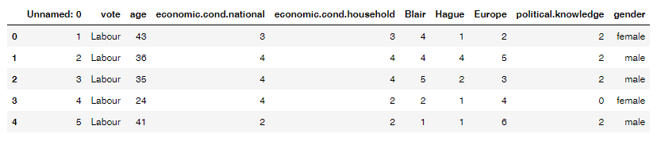
Table 1.1: Sample Data Set

- The dataset has a total of 9 variables with 1 continuous variables, six ordinals type variables and two categorical variables.
- Shape (Dimension of the dataset is 1525, 10)
- There were zero null values present in the dataset.
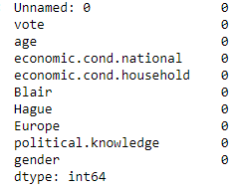
Table 1.2: Null Values

- Data Types: The dataset contains both Object, Int data types.
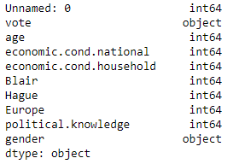
Table 1.3: Data Types
- Duplicate Values: There are no duplicate values present and in this particular Dataset duplicate values does not infer much because two or more voters may be having same ordinal values as others.
- To perform the Univariate analysis, let us start with looking at the summary of the dataset:
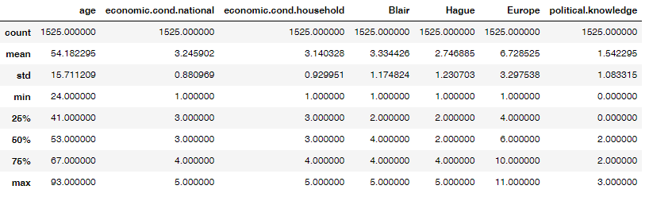
Table 1.4: Statistical Summary of the Dataset

- Inferences:
- The minimum age of a voter is 24 and the maximum age of a voter is 67.
- More than 75 % of the voters are under current National Economic Condition and same apples to Current household economic conditions.
- Only 25% of the voters having the less attitude towards the European integration.
- As most of the variables in the dataset are ordinal in nature, we are unable to draw much inference.

1.2 Perform Univariate and Bivariate Analysis. Do exploratory data analysis. Check for Outliers. (7 Marks)
Univariate Analysis:
Distribution and Box Plots:
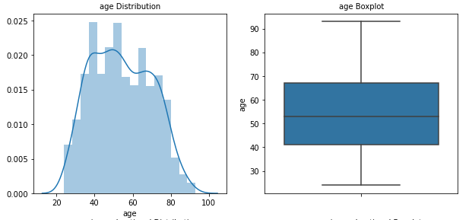
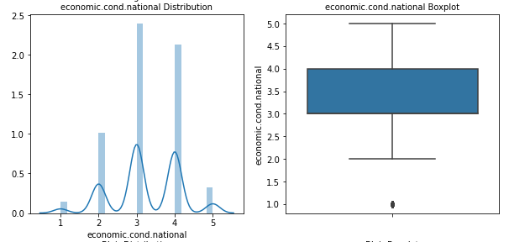

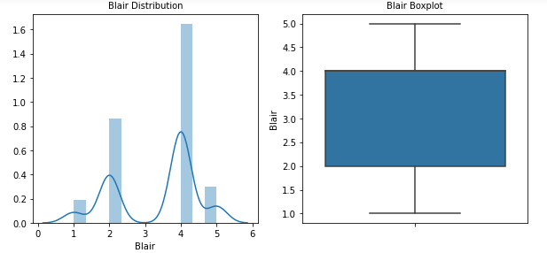
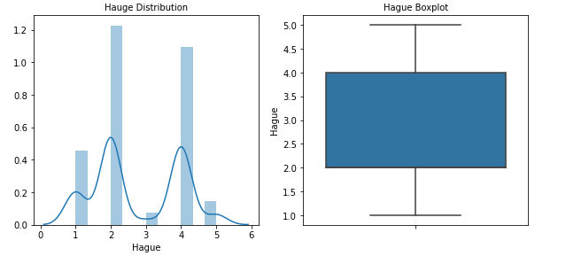
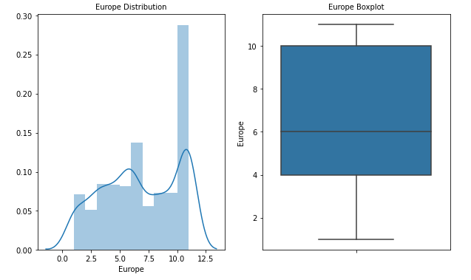
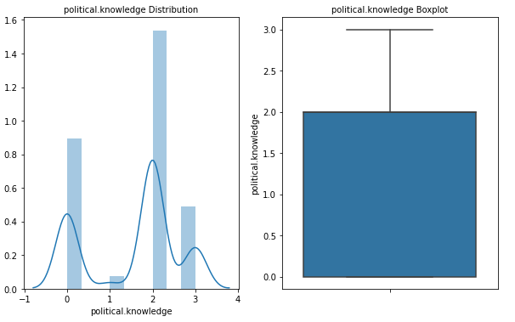
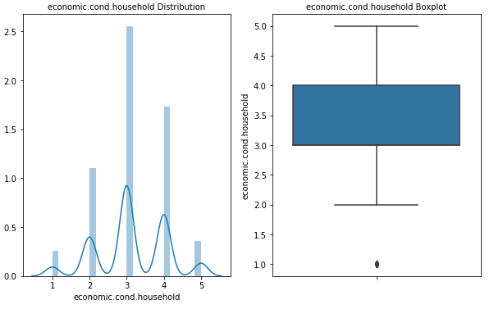
Fig 1.1 Distribution and Box Plots on Continuous Variables and Ordinal variables

Inferences from Univariate Analysis:
- From the box plots we can conclude that there are only few outliers present in the Household Economic Conditions and National Economic conditions which are ordinal dataset so as there is no need to treat the outliers.
- Age variable has no variables and is having normal distribution.
- Most of the variables particularly the ordinal variables are bimodal or multi modal distributions.
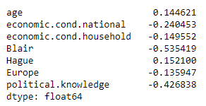
Table 1.5: Skewness
- Only two variables of Age and Hague have positive skewness i.e., it is right skewed and all other variables are left skewed.

Categorical variable Analysis:
Inferences of Categorical Variables:
- Most of the voters have voted for Labor party i.e, 69.7% while other opted for conservative party.
- Female respondents are higher than the male respondents.
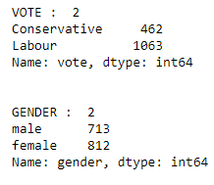
Table 1.6: Categorical Variable Analysis
Bi-variate Analysis:
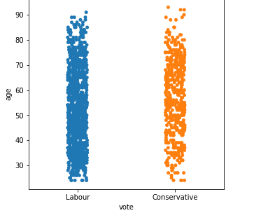
Fig 1.2 Bi variate analysis on age
From the above fig it is evident that, most of the lower age group voters preferred the Labour party than the conservative party.
As all other Int Objects are ordinal variables the data is not showing any pattern as a result there is no much useful information can be inferred.
Multi-variate Analysis:
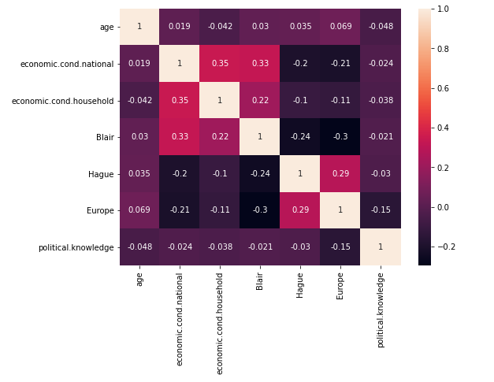
Fig 1.3: Correlation Matrix
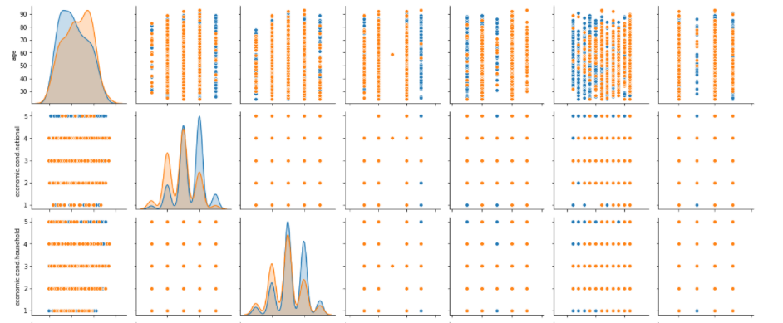
Fig 1.4: Sample Pair plot

Inferences from Multi-Variate Analysis:
- There is no correlation between the variables
- It is evident that from the pair plot it is evident that, there is no patter among the variables majorly because most of the variables in the date set are ordinal.

1.3 Encode the data (having string values) for Modelling. Is Scaling necessary here or not? Data Split: Split the data into train and test (70:30).
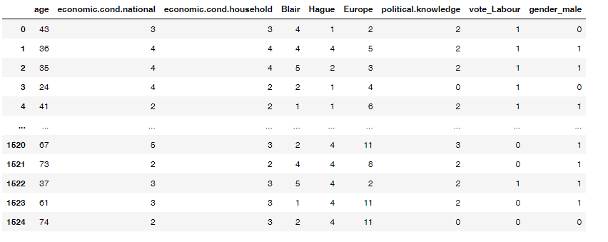
Table 1.7: Encoded Dataset
- Categorical Variables are encoded using get_dummies and the sample dummies data set is shown in the above table.
- Scaling: Scaling is necessity when using the Distance-based models such as KNN etc., Here in this case there both categorical and ordinal variable and scaling can be done on both the type of variables. But here we use scaling while performing the KNN models.
- After performing the train and test split data the class distribution on train and test data is as follows:
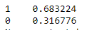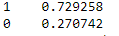
- From the above distribution we can say that there is no class imbalance in the dataset.

1.4 Apply Logistic Regression and LDA (linear discriminant analysis).

Logistics Regression:
Upon splitting the data into train and test dataset the Logistics Regression model is being applied and the model scores and matrices are as follows:
The Model Score on the Train Data is: 0.83 or 83%
The Model Score on the Test Data is: 0.82 or 82%
As the model score is performing well on the test and also on the train the model is fitted well on both train and test data.
AUC Score for the train dataset is: 0.898 or 89%
AUC Score for the test dataset is: 0.898 or 89%
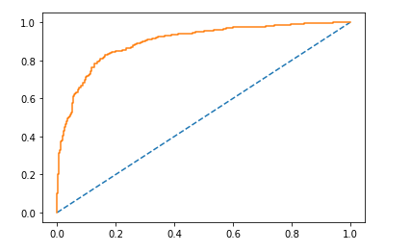
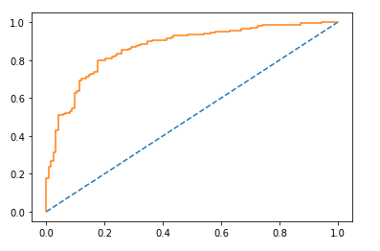
ROC Train data ROC Test Data
Fig 1.5: ROC Curve on Training and Test Data for Linear Regression
By observing both the datasets, it is evident that more or less the model is performing well on both train as well as test data.
Let us also look at the Classification report on both Train and Test Data.
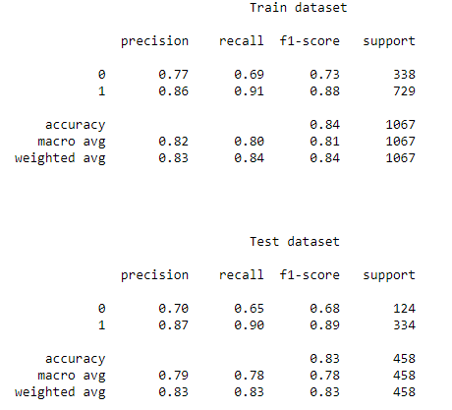
Table 1.8: Classification report on Train and Test Data for Linear Regression
Inferences on Classification report:
- Here in this problem, both recall and precision are important for analysis and prediction.
- Recall on Train data: 0.91
- Recall on Test data: 0.90
- Precision on Train data: 0.86
- Precision on Test data: 0.87
- Accuracy Train: 0.84
- Accuracy Test: 0.83
From the given business problem it is quite clear that we need to look for accuracy and recall values as the entire business problem depends on the True Positives i.e., actual voters correctly classified.
Here in this case the recall score on both train and test data are more or less same and the model is a good model.
Logistics Regression with GRID SEARCH CV:
grid={'penalty':['l2','none'],'solver':['sag','lbfgs'], 'tol':[0.0001,0.00001]}
With the above grid we have performed the GRID SEARCH CV and obtained the model as follows:
AUC Score for the train dataset is: 0.898 or 89%
AUC Score for the test dataset is: 0.898 or 89%
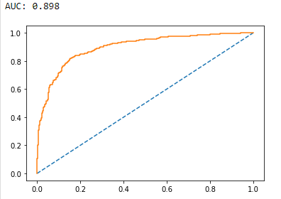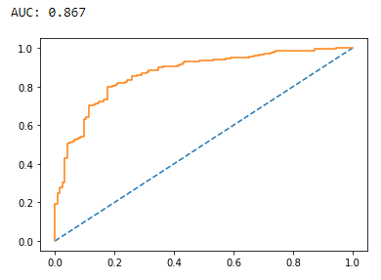
Fig 1.6: ROC Curve on Training and Test Data for LR-Grid Search
By observing both the datasets, it is evident that more or less the model is performing well on both train as well as test data.

Let us also look at the Classification report on both Train and Test Data.

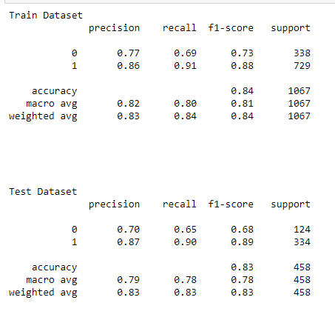
Table 1.9: Classification report on Train and Test Data for LR Grid Search

Inferences on Classification report:
- Here in this problem, both recall and precision are important for analysis and prediction.
- Recall on Train data: 0.91
- Recall on Test data: 0.90
- Precision on Train data: 0.86
- Precision on Test data: 0.87
- Accuracy Train: 0.84
- Accuracy Test: 0.83

From the given business problem it is quite clear that we need to look for accuracy and recall values as the entire business problem depends on the True Positives i.e., actual voters correctly classified.
Here in this case the recall score on both train and test data are more or less same and the model is a good model.
Both model with and without GRID SEARCH is performing well

Linear Discriminant Analysis:
AUC Score for the train dataset is: 0.898 or 89%
AUC Score for the test dataset is: 0.898 or 89%
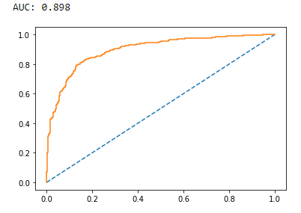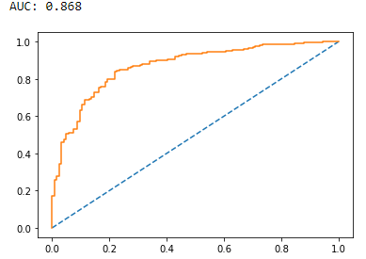
Fig 1.7: ROC Curve on Training and Test Data for LDA
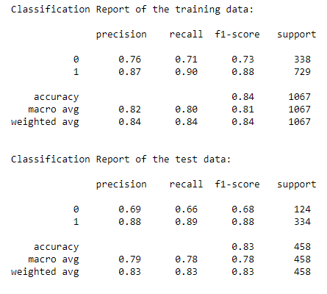
Table 1.10: Classification report on Train and Test Data for LDA

Inferences on Classification report:
- Recall on Train data: 0.90
- Recall on Test data: 0.89
- Precision on Train data: 0.87
- Precision on Test data: 0.88
- Accuracy Train: 0.84
- Accuracy Test: 0.83
From the given business problem it is quite clear that we need to look for accuracy and recall values as the entire business problem depends on the True Positives i.e., actual voters correctly classified.
Here in this case the recall score on both train and test data are more or less same and the model is a good model.
Both Logistics regression Linear Discriminant Analysis models are performing and predicting the models well. Hence both are good models.

1.5 Apply KNN Model and Naïve Bayes Model. Interpret the results.
Naïve Bayes:
Upon splitting the data into train and test dataset the Naïve bayes model is being applied and the model scores and matrices are as follows:
The Model Score on the Train Data is: 0.84
The Model Score on the Test Data is: 0.81
As the model score is performing well on the test and also on the train the model is fitted well on both train and test data.
AUC Score for the train dataset is: 0.894
AUC Score for the test dataset is: 0.866
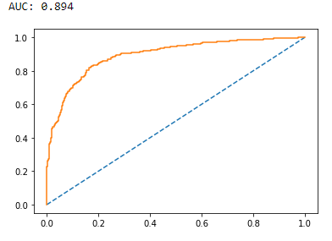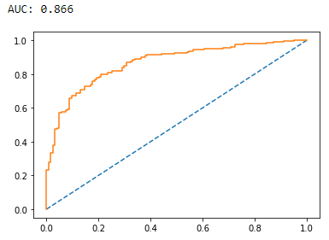
Fig 1.8: ROC Curve on Training and Test Data for Naïve Bayes

Classification Report on Train data:
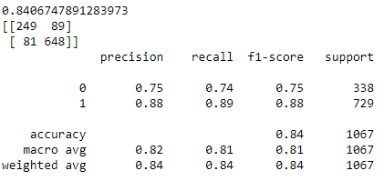
Classification Report on Test data:
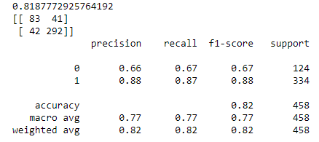
Table 1.11: Classification report on Train and Test Data for Naïve Bayes

Inferences on Classification report:
- Recall on Train data: 0.89
- Recall on Test data: 0.87
- Precision on Train data: 0.88
- Precision on Test data: 0.88
- Accuracy Train: 0.84
- Accuracy Test: 0.82
From the given business problem it is quite clear that we need to look for accuracy and recall values as the entire business problem depends on the True Positives i.e., actual voters correctly classified.
Here in this case the recall score on both train and test data are more or less same and the model is a good model.
Naïve Bayes model also seems good.
KNN Model:
Kneighbours classfifier is checked with different n_neighbors with k= 3,4,5,6,… with euclidean distance. The accuracy scores for the same are:
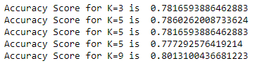
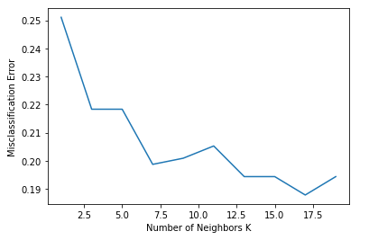
From the above graph it is quite evident that the neighbors are not following a pattern and it is difficult to find one neighbor to go with KNN Classifier.
For example, at k=3, the model is under fitting.
So in this case the KNN model has been executed by not giving any specific k values and the classification report is as follows:
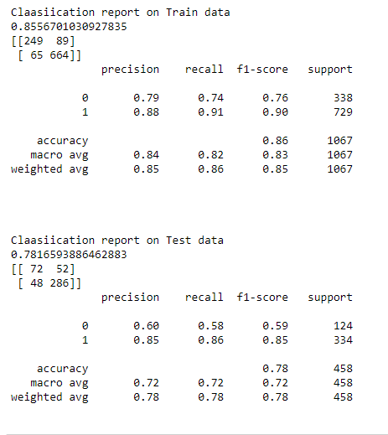
Table 1.12: Classification report on Train and Test Data for KNN

Inferences on Classification report:
- Model Score on Train Data: 0.85
- Model Score on Test Data: 0.75
- Recall on Train data: 0.91
- Recall on Test data: 0.86
- Precision on Train data: 0.88
- Precision on Test data: 0.72
- Accuracy Train: 0.86
- Accuracy Test: 0.78
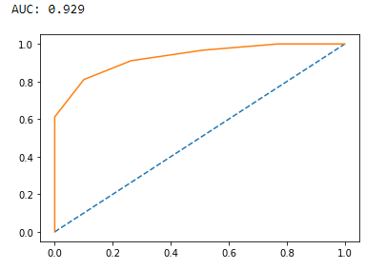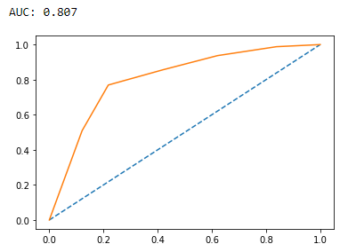
Fig 1.9: ROC Curve on Training and Test Data for KNN

AUC Score on Train data: 0.92
AUC Score on Test data: 0.80
From the given business problem it is quite clear that we need to look for accuracy and recall values as the entire business problem depends on the True Positives i.e., actual voters correctly classified.
Here in this case the model seems to be overfitting.

1.6 Model Tuning, Bagging (Random Forest should be applied for Bagging), and Boosting.
Bagging on Random Forest:
Bagging, also known as the bootstrapping aggregation, is the ensemble technique that is commonly used to reduce the variance with in a noisy dataset. The random forest algorithm is considered an extension of the bagging method, using both bagging and feature randomness to create an uncorrelated forest of decision tress.
- Classification Report on Random Forest:
Train data:
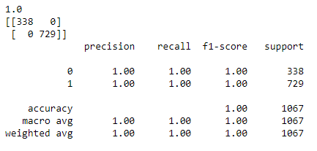
Test data:
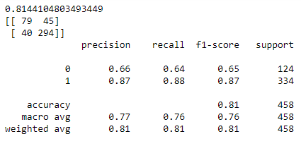
Table 1.13: Classification report on Train and Test Data for RF

From the above classification report it is clearly evident that, the model is overfitting as there is a lot of variance/noise present so let us deal this with the method of bagging.
Bagging:
AUC Score on Train data: 0.998
AUC Score on Test data:
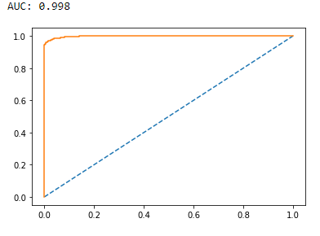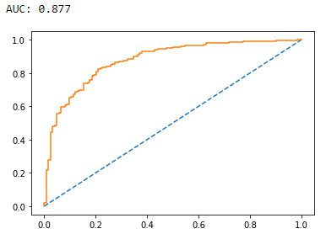
Fig 1.10: ROC Curve on Training and Test Data for Bagging

From the above graph it is clear that, training dataset shows may perform the model well but on the testing data the model is poor and this is a clear set of model overfitting let us see the classification reports:
Classification report on Training Data:
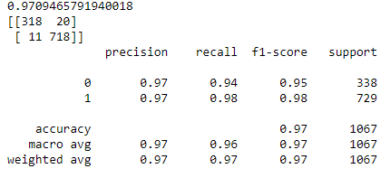
Classification report on Test Data:
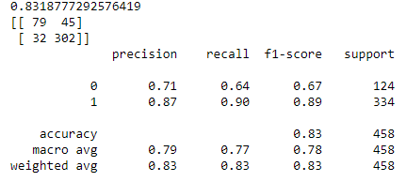
Table 1.14: Classification report on Train and Test Data for Bagging

Inferences on Classification report:
- Model Score on Train Data: 0.97
- Model Score on Test Data: 0.75
- Recall on Train data: 0.98
- Recall on Test data: 0.90
- Precision on Train data: 0.97
- Precision on Test data: 0.87
- Accuracy Train: 0.97
- Accuracy Test: 0.83
From the above data we can say that, the model is performing well on the train data and poorly on the test data.

Boosting:
ADA Boosting:
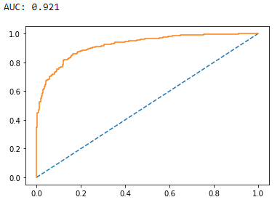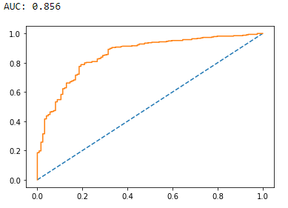
Fig 1.11: ROC Curve on Training and Test Data for AdaBoosting

Classification report on Train data:
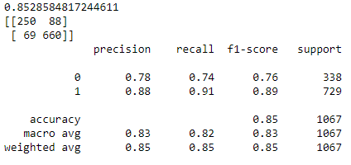
Classification report on Test data:
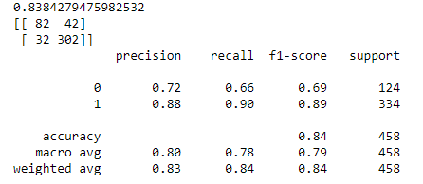
Table 1.15: Classification report on Train and Test Data for AdaBoosting

Gradient Boosting:
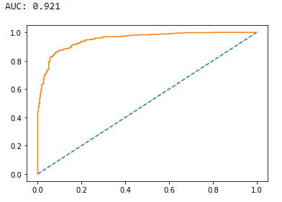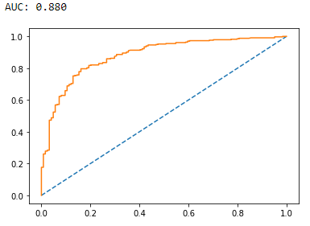
Fig 1.12: ROC Curve on Training and Test Data for Gradient Boosting

Classification report on Train data:
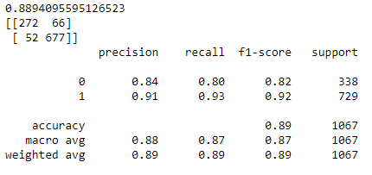
Classification report on Test data:
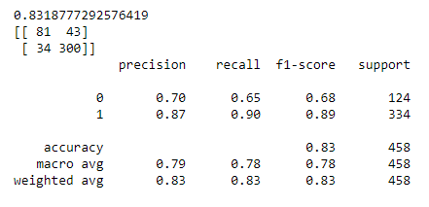
Table 1.16: Classification report on Train and Test Data for Gradient Boosting

Inferences on both AdaBoosting and Gradient Boosting:
Parameters | AdaBoosting Train data | AdaBoosting Test data | Gradient Boosting Train data | Gradient Boosting Test data
AUC Score | 0.92 | 0.85 | 0.92 | 0.88
Model Score | 0.85 | 0.83 | 0.88 | 0.83
Accuracy | 0.85 | 0.84 | 0.89 | 0.93
Precision | 0.88 | 0.88 | 0.91 | 0.87
Recall | 0.91 | 0.90 | 0.93 | 0.90
Table 1.17: Inferences on both AdaBoosting and Gradient Boosting

From the above table it is evident gradient boosting is performing better than the Adaboositng the score on train data is good and model is performing well on test as well.
Let’s Check the apply SMOTE:
SMOTE is used when there is class imbalance. As in this case there is no much class imbalance but we have observed the data is overfitting let us try and use the SMOTE on Naïve Bayes algorithm and KNN Classifier and see the results:
Naïve Bayes SMOTE Model:
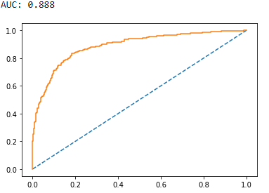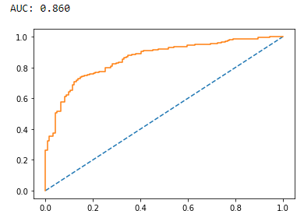
Fig 1.13: ROC Curve on Training and Test Data for Naïve Bayes using SMOTE

Classification report on Train data:
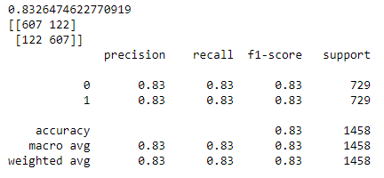
Classification report in Test data:
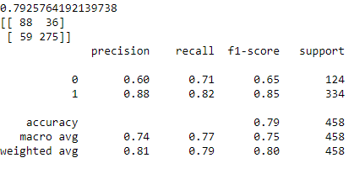
Table 1.18: Classification report on Train and Test Data for Naïve Bayes using SMOTE
KNN Classifier Using SMOTE:
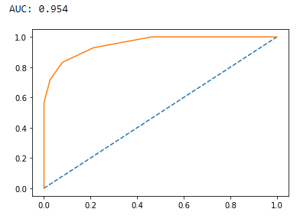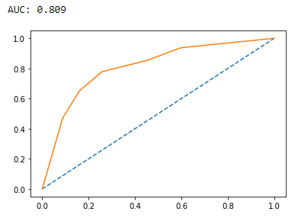
Fig 1.14: ROC Curve on Training and Test Data for KNN Using SMOTE

Classification report on Train data:
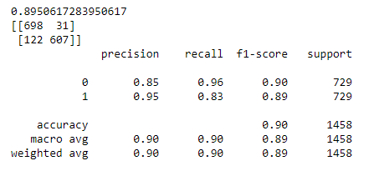
Classification report on Test Data:
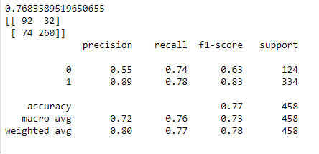
Table 1.19: Classification report on Train and Test Data for KNN using SMOTE
Inferences on SOMTE technique:
Parameters | NAÏVE BAYES using SMOTE on train | NAÏVE BAYES using SMOTE on test | KNN Using SMOTE on train | KNN Using SMOTE on test
AUC Score | 0.88 | 0.86 | 0.95 | 0.80
Accuracy | 0.83 | 0.79 | 0.89 | 0.76
Precision | 0.83 | 0.88 | 0.95 | 0.89
Recall | 0.83 | 0.82 | 0.83 | 0.78
Table 1.20: Inferences on SOMTE technique:
From the above data it is clear that when SMOTE Used Naïve Bayes is performing well and can be treated as a good model.

1.7 Performance Metrics: Check the performance of Predictions on Train and Test sets using Accuracy, Confusion Matrix, Plot ROC curve and get ROC_AUC score for each model. Final Model: Compare the models and write inference which model is best/optimized.
MODEL CAPARISION:
 | AUC SCORE | ACCURACY | PRECISION | RECALL | F1 SCORE
LR Train | 0.89 | 0.84 | 0.86 | 0.91 | 0.88
LR Test | 0.89 | 0.83 | 0.87 | 0/90 | 0.89
LR Grid Search Train | 0.89 | 0.84 | 0.86 | 0.91 | 0.88
LR Grid Search Test | 0.86 | 0.83 | 0.87 | 0.90 | 0.89
LDA Train | 0.89 | 0.84 | 0.87 | 0.90 | 0.88
LDA Test | 0.86 | 0.83 | 0.88 | 0.89 | 0.88
NB Train | 0.89 | 0.84 | 0.88 | 0.89 | 0.88
NB Test | 0.86 | 0.82 | 0.88 | 0.87 | 0.88
KNN Train | 0.92 | 0.86 | 0.88 | 0.91 | 0.90
KNN Test | 0.80 | 0.78 | 0.85 | 0.86 | 0.85
RF Train |  | 1 | 1 | 1 | 1
RF Test |  | 0.81 | 0.87 | 0.88 | 0.87
Bagging Train | 0.99 | 0.97 | 0.97 | 0.98 | 0.98
Bagging Test | 0.87 | 9.83 | 0.87 | 0.90 | 0.89
AdaBoosting Train | 0.92 | 0.85 | 0.88 | 0.91 | 0.89
AdaBoosting Test | 0.85 | 0.84 | 0.88 | 0.90 | 0.89
Gradient Train | 0.92 | 0.89 | 0.91 | 0.93 | 0.92
Gradient Test | o.88 | 0.83 | 0.87 | 0.90 | 0.89
NB SMOTE Train | 0.88 | 0.83 | 0.83 | 0.83 | 0.83
NB SMOTE Test | 0.86 | 0.79 | 0.88 | 0.82 | 0.85
KNN SMOTE Train | 0.95 | 0.90 | 0.95 | 0.83 | 0.89
KNN SMOTE Test | 0.80 | 0.77 | 0.89 | 0.78 | 0.83
Table 1.21:Model Comparison Table

Inference:
For the problem given, we need to predict which party a voter will vote so that exit polls can be predicated. So here we needed to check the Voters to voted correctly to the respective party i.e., focus on True Positives, Sensitivity, Recall. Here Precision is also as important as the recall but weightage will go to recall as we need to check the true positives.
From the comparison table we can say that we can suggest the Linear Regession Model with or without GRID Search, LDA and Naïve bayes and naïve bayes with SMOTE. We can further tune the model and get a very good performing model.

1.8 Based on these predictions, what are the insights?

- It will be good to evaluate if the data in either continues or discreet form.
- The range of the ordinal values also differ from other ordinal value range.
- More than one model is performing better in this particular dataset. So if more uniform data is available we can narrow down to good performing model.
- By observing two to three models, we can say that, more than 80% of the voters can rightly predict which party a voter will vote.
- The model needs to be studied more carefully to acquire the sensitivity of the prediction.

